

**CMC CONSUMER MEDICAL CARE PAMUK AMBALAJ SAN. VE TİC. LTD.ŞTİ.**

**EMPLOYEE CANDIDATE EXPLICIT CONSENT TEXT**

**Responsible Party and Contact Information**

|  |  |
| --- | --- |
| **Responsible Party:**  CMC CONSUMER MEDICAL CARE  PAMUK AMBALAJ SAN. VE TİC.LTD.ŞTİ. KARADUVAR MAH. SERBEST BÖLGE  FREE ZONE 6. CADDE DIŞ KAPI NO:25  İÇ KAPI NO: 2 33020 AKDENİZ MERSİN  TURKEY  Phone: +90 324 239 38 70  Fax: +90 324 239 38 73 E-Mail: [selim.turhan@cmc-group.com.tr](mailto:selim.turhan@cmc-group.com.tr) | **Data Controller Contact Person:**  CMC CONSUMER MEDICAL CARE  PAMUK AMBALAJ SAN. VE TİC. LTD.ŞTİ.  KARADUVAR MAH. SERBEST BÖLGE  FREE ZONE 6. CADDE DIŞ KAPI NO:25  İÇ KAPI NO: 2 33020 AKDENİZ MERSİN  TURKEY  E-Mail: [mustafa.topacik@cmc-group.com.tr](mailto:mustafa.topacik@cmc-group.com.tr) |

Explicit consent; means the consent that is based on being informed about a certain subject and that is expressed with free will, and this explicit consent text; contains information on certain topics listed below, and we would like to remind you that you are free to approve or disapprove this text.

Since you are an employee candidate of CMC CONSUMER MEDICAL CARE PAMUK AMBALAJ SAN. VE TİC. LTD. ŞTİ. (“Company”), which has the title of data controller under the Law on Protection of Personal Data No. 6698; We request, within the scope of the processing of your personal data, except for the exceptions under the Personal Data Protection legislation (necessary for the establishment of the contract or the legitimate interest of the data controller) your explicit consent regarding the following matters.

For the purposes of checking references and conducting the necessary research within the scope of the job application processes for the vacant position within your company, and evaluating my resume for a suitable position that may arise in the future in the event I was not recruited for this position,

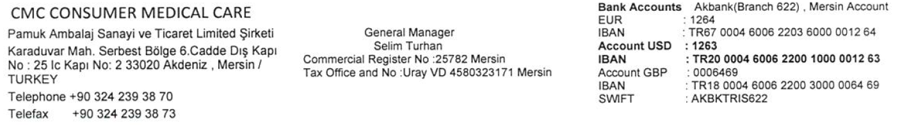



I Explicitly and under my free will consent to your company may process my identity data, health data and personal data that I shared with your company during the examination of my application for an open position within your company, including my sensitive personal data (nationality, criminal conviction and security measures information, blood group, health data, biometric data) and to its sharing and keeping with the relevant authorities of the Company and the Holding abroad, to which our company is affiliated,

I Accept

I Decline

|  |  |
| --- | --- |
| Data Owner |  |
| Name and surname |  |
| Date |  |
| Signature |  |

